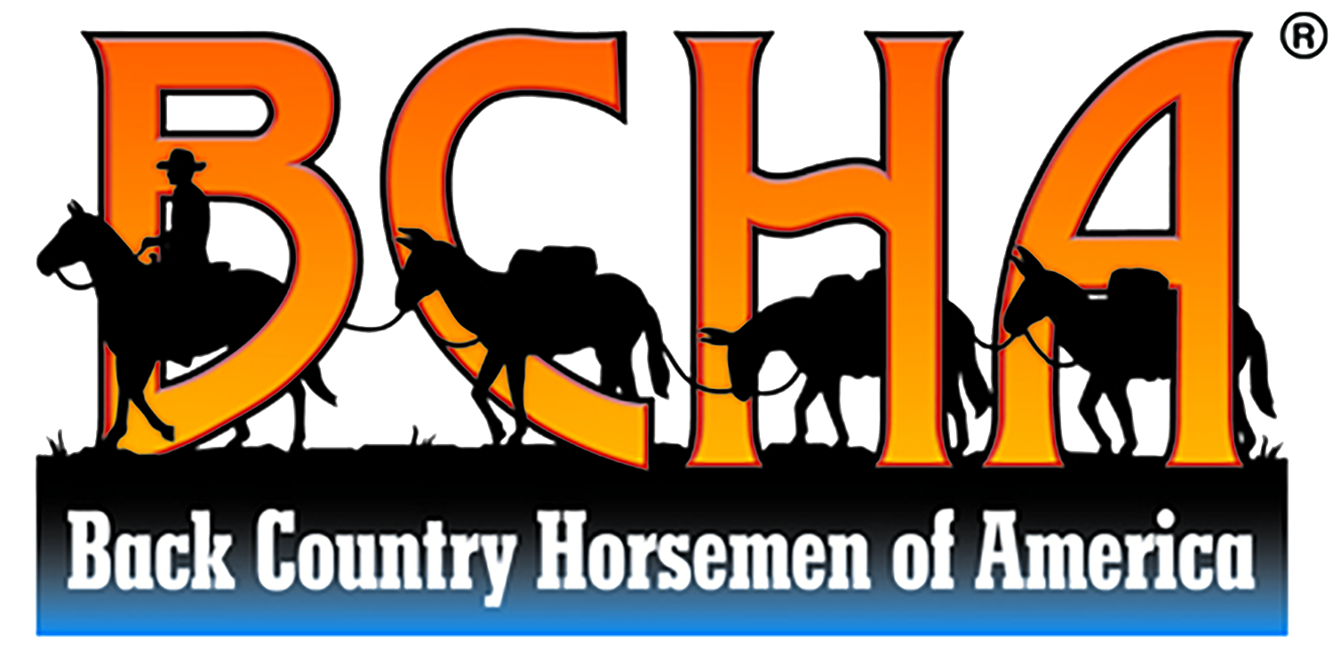

Sept. 27th, 2025 BCHoTN Rendezvous
Timber Ridge Campground in Jamestown, TN

MURDER MYSTERY EVENT:

Golden Outlaws

Schedule

9 a.m. Breakfast | Dining Hall
10 a.m. Opening Skit | Dining Hall
10:30 a.m. Pick Your Posse
11 a.m. Hit the Trail | BSF Side
12 – 1:30 P.m. Lunch on the Trail
5 p.m. Dinner | Dining Hall
6 P.m. Closing Skit & Final Guesses

Setting the Opening Scene
This is how Skit #1 will begin

At the saloon, locals gather for morning vittles. There are two distinct groups in the room: the bounty hunter posses and the sheriff with his deputies. While Sheriff Grimshaw isn’t particularly fond of the bounty hunters, he occasionally makes use of their services when his own men are stretched too thin.
The bounty hunters find work, typically as ranch hands, between chases. They’re drifters, beholden to no one place, and free as the wind. While they aren’t known for being particularly moral people, they have their own sense of justice.
Bursting into the saloon and startling Sheriff Grimshaw to his feet, young Pierre cries, “It’s my Pa! He’s–he’s...!” Pierre stumbles, blubbering. “He’s dead!”
Hurrying to the door, Grimshaw follows Pierre’s pointed finger. Slung over the back of his own horse lies Jeb.

CONTEXT: JEB (the Victim) & PIERRE (the Victim’s Son)
This section helps you (the actor for either Jeb or Pierre) understand your character. Though, if you’re Jeb’s actor, you don’t have to understand much. You just have to pretend to be dead. Lol.
The miner Jeb and his 15 year-old son Pierre spend years testing the mountain streams, panning for gold flakes. Quite by mistake, Jeb discovers a hidden map to a stash of Spanish gold. Tucked away inside a sealed clay jar and tucked into the back of a small cave, the paper is old, but not ancient. Although Jeb can’t read, he recognizes the indicated terrain on the map. The map is partially damaged, but he’s followed it to a large valley and has been carefully combing it for years. Jeb keeps the map with him always, as he doesn’t want anyone else discovering it.
The valley is very remote. Jeb sees few people, save the same few fur trappers. He never learns their names, as he’s rather secretive of his own mission. The trappers eventually stop offering to trade with Jeb, as he always sends them away.
Jeb’s only companion is his son Pierre, whom he forces to work alongside him, searching for the treasure. As Pierre nears adulthood, he begins to resent his father more and more. Each day, his father’s mad ramblings and obsession drive Pierre to sharp anger. Why should he spend his life wasting away in this valley for a treasure that’s obviously not here?
When Jeb finally digs up several gold coins outside another cave, he’s elated, but knows that the full stash has yet to be discovered. Distrustful of his rebellious son, Jeb hides the coins from him. He suspects that Pierre may steal the coins and skip town with them. The miner doubles his efforts, however, he’s growing older; he needs to make progress more quickly. He uses some of his coins to buy better tools, dynamite, and an old horse to carry loads.
Everyone in town suspects that Jeb finally made good on a gold claim; he was rarely seen in town and had never afforded to buy so much at once. No one knows much about him. Claim stakers sometimes attempt to follow Jeb into the wilderness, but he is notoriously good at shaking a tail.
Jeb suspects that the stash might be contained within an unknown cave under one of the big rockslides in the valley. So, he gets to work digging, blasting, and carting away rubble with his nag. His spirits rise when he begins finding pottery shards in the rockslide. This only irritates Pierre. After a huge screaming match, Pierre storms to town, vowing to never step foot in that forsaken valley again.

SHERIFF GRIMSHAW & PIERRE
This story and information is known only to you and the event organizer, prior to the event. This backstory simply helps you understand your character and any possible motives your character might have.
Get creative! How do you think your character might speak, dress, or act? The more invested you are, the more fun for everyone!
Pierre is determined to become independent. He dreams of owning a ranch, and the only way to do that is by making money—not a fool’s treasure hunt. Pierre tries odd jobs in Timber Ridge, finally landing on a low-level jailer position. He cooks, cleans, and cares for the prisoners in the jail. He also finds an affinity for creating Wanted posters, which are distributed to the bounty hunters whenever Sheriff Grimshaw hires out additional help.
During long-night shifts, Pierre explains his life to the sheriff. He evens speaks of his pa and his crazy obsession. Grimshaw takes some interest in Pierre’s father, asking if he’s still alive, still looking for that treasure. Pierre huffs in annoyance, stating that Jeb will die of old age before he finds anything in that cursed valley.
Sheriff Grimshaw nods in agreement, wishing he’d stumble upon a jackpot; he really needed one himself. At that moment, a rough knock sounds upon the jail door as it swings open. Grimshaw inwardly cringes as Buck Cletus sweeps into the room, several of his cronies in tow.
The leader of the Cletus gang, Buck is exactly the sort of man who makes the sheriff seethe. He’s cunning and untrustworthy, yet stays just within the rule of law so that Grimshaw can’t take action against him or his men. And, unfortunately, Buck’s bounty hunters recently bagged several wanted men. So many that Grimshaw was unable to pay out their outrageously high bounty fees and had been stalling for time. He had no idea when government bounty reimbursements were due for a restock—usually only once a year. But he couldn’t tell that to Buck.
“Grimshaw.” Buck drawled out the word. “Fine night.”
The sheriff sighed. “Look, I know why you’re here, Cletus. There’s still nothing in my vault to pay you. You’re just gonna have to wait.”
“Oh, but I don’t think I will.”
“And why’s that?”
Tense, Pierre notices how Grimshaw’s hand subtly moves to his holstered revolver.
“I dunno if ya’ll’s noticed, but there’s quite a few of us now. Lots ‘o mouths to feed.” Buck gestures outside, where nigh on twenty men are gathered on horseback.
Flicking his eyes back to the gang leader, Grimshaw shrugs. “And?”
“And…” Cletus imitates the shrug, speaking with a clipped pause between words. “Not so many of you.”
Grimshaw’s expression hardens at the threat. Buck isn’t wrong. With only four officers and one boy in the force, they wouldn’t stand much chance in an all-out firefight. The Cletus gang would likely take the town.
“I’ll give you… hmm…” Cletus taps his stubbly chin, pondering, as if he hadn’t pre-planned every word. “Ten days. Good night, sheriff.” He says the title mockingly before spinning on his heel, entourage sneering greedily as they exit.
Grimshaw sinks wearily into his chair.
“Sir?” squeaks Pierre, finding his voice after the men thunder away.
“Boy,” says the sheriff non-commitally.
“They wouldn’t really…?”
“Yes. They would. They expect payment or my head. And I’ve no plan. Maybe…” the sheriff laughs harshly. “I should go join your father in his treasure hunt.”

