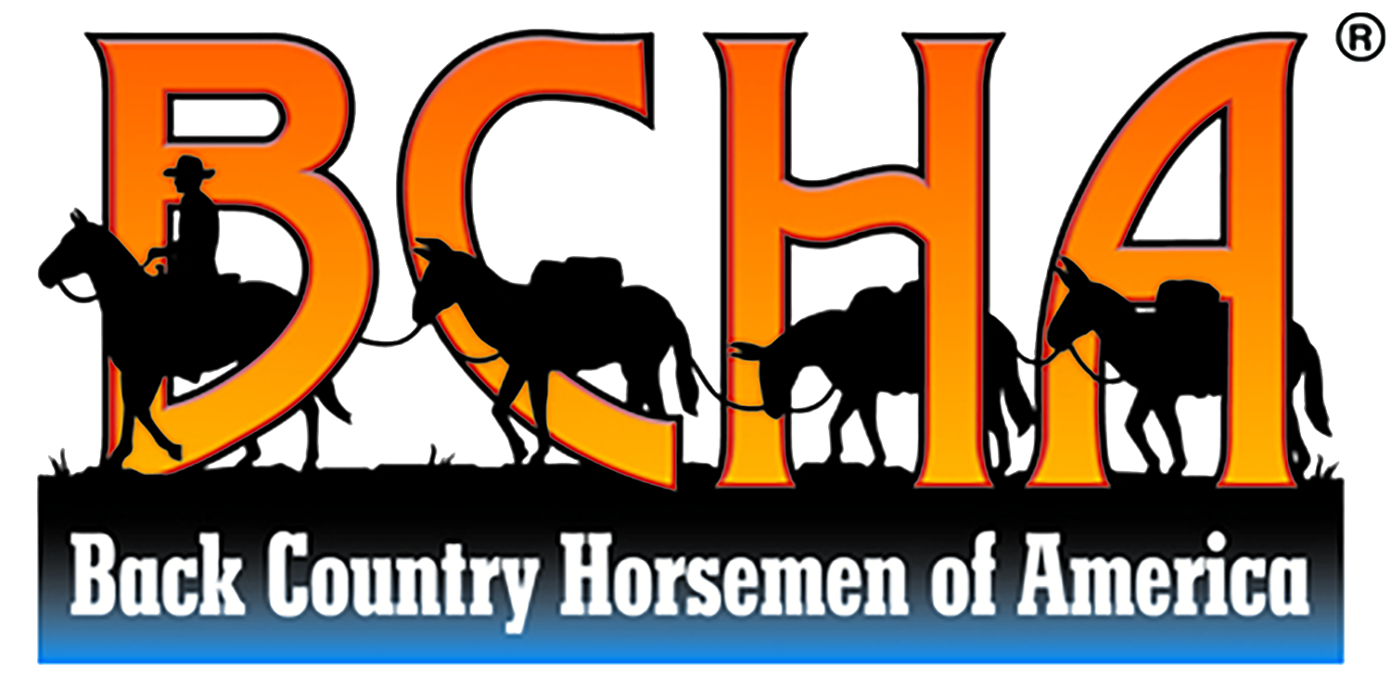

Sept. 27th, 2025 BCHoTN Rendezvous
Timber Ridge Campground in Jamestown, TN

MURDER MYSTERY EVENT:

Golden Outlaws

Schedule

9 a.m. Breakfast | Dining Hall
10 a.m. Opening Skit | Dining Hall
10:30 a.m. Pick Your Posse
11 a.m. Hit the Trail | BSF Side
12 – 1:30 P.m. Lunch on the Trail
5 p.m. Dinner | Dining Hall
6 P.m. Closing Skit & Final Guesses

Setting the Opening Scene
This is how Skit #1 will begin

At the saloon, locals gather for morning vittles. There are two distinct groups in the room: the bounty hunter posses and the sheriff with his deputies. While Sheriff Grimshaw isn’t particularly fond of the bounty hunters, he occasionally makes use of their services when his own men are stretched too thin.
The bounty hunters find work, typically as ranch hands, between chases. They’re drifters, beholden to no one place, and free as the wind. While they aren’t known for being particularly moral people, they have their own sense of justice.
Bursting into the saloon and startling Sheriff Grimshaw to his feet, young Pierre cries, “It’s my Pa! He’s–he’s...!” Pierre stumbles, blubbering. “He’s dead!”
Hurrying to the door, Grimshaw follows Pierre’s pointed finger. Slung over the back of his own horse lies Jeb.

CONTEXT: JEB (the Victim) & PIERRE (the Victim’s Son)
This section helps you (the actor) understand Jeb (the victim) or his son (Pierre), with whom you interact in your backstory.
The miner Jeb and his 15 year-old son Pierre spend years testing the mountain streams, panning for gold flakes. Quite by mistake, Jeb discovers a hidden map to a stash of Spanish gold. Tucked away inside a sealed clay jar and tucked into the back of a small cave, the paper is old, but not ancient. Although Jeb can’t read, he recognizes the indicated terrain on the map. The map is partially damaged, but he’s followed it to a large valley and has been carefully combing it for years. Jeb keeps the map with him always, as he doesn’t want anyone else discovering it.
The valley is very remote. Jeb sees few people, save the same few fur trappers. He never learns their names, as he’s rather secretive of his own mission. The trappers eventually stop offering to trade with Jeb, as he always sends them away.
Jeb’s only companion is his son Pierre, whom he forces to work alongside him, searching for the treasure. As Pierre nears adulthood, he begins to resent his father more and more. Each day, his father’s mad ramblings and obsession drive Pierre to sharp anger. Why should he spend his life wasting away in this valley for a treasure that’s obviously not here?
When Jeb finally digs up several gold coins outside another cave, he’s elated, but knows that the full stash has yet to be discovered. Distrustful of his rebellious son, Jeb hides the coins from him. He suspects that Pierre may steal the coins and skip town with them. The miner doubles his efforts, however, he’s growing older; he needs to make progress more quickly. He uses some of his coins to buy better tools, dynamite, and an old horse to carry loads.
Everyone in town suspects that Jeb finally made good on a gold claim; he was rarely seen in town and had never afforded to buy so much at once. No one knows much about him. Claim stakers sometimes attempt to follow Jeb into the wilderness, but he is notoriously good at shaking a tail.
Jeb suspects that the stash might be contained within an unknown cave under one of the big rockslides in the valley. So, he gets to work digging, blasting, and carting away rubble with his nag. His spirits rise when he begins finding pottery shards in the rockslide. This only irritates Pierre. After a huge screaming match, Pierre storms to town, vowing to never step foot in that forsaken valley again.

YOUR BACKSTORY: EZRA THE ARCHAEOLOGIST (MALE EDITION)
This story and information is known only to you and the event organizer, prior to the event. This backstory simply helps you understand your character and any possible motives your character might have.
Get creative! How do you think your character might speak, dress, or act? The more invested you are, the more fun for everyone!
Jeb’s recent decline in health frightens him. If he is unable to continue his treasure hunt—and especially if he dies without unearthing it—he’ll have wasted half his life on a fool’s errand. He needs help, and now that his rotten son Pierre (curse him) has abandoned him, his options are limited. So when an archaeologist comes through, surveying the valley for something called fossils, Jeb entreats his services.
The archaeologist, Ezra, is a tall man. He’s young, wiry, and fast-speaking. He seems always in a hurry, as if the dead lizard bones he searches for may up and run away. Ezra riffles through parchment sheets, selecting one from his collection. On the paper is a detailed sketch of a reconstructed “dinosaur” skeleton. However, what interests Jeb is the myriad of scratchy writing all around the drawing.
Based on Ezra’s deep understanding of old languages, Jeb’s almost positive that the eccentric archaeologist could decode his treasure map. In Jeb’s mind, time is running short. Perhaps the map text says nothing important; perhaps it is indeed mindless rabble. Or, perhaps… his years of guesswork would finally sharpen into a clear directive.
So, for the very first time, Jeb decides to share the map with someone other than his son.
“This here paper... Ah found it nearby, and got t’thinkin’ that you might could read it.” Jeb produces the brittle sheet from his coat pocket.
Intrigued, the scholar accepts the relic with gloved hands. Angling the paper to catch more light, his eyes skim the surface.
“Spanish?” he entreats Jeb, noticing the anxious expression the man wears.
“Could be. Never learned words.”
Ezra’s face scrunches as he works at deciphering the flowing Spanish script. He isn’t particularly familiar with Spanish. French and Latin are his specialty, however, he knows that with enough time, he could complete the translation.
Finally taking note of the imagery, something clicks for Ezra. “Wait a minute. This is a treasure map? Seriously? How did you of all people come across something like this?”
“No mind to that! I found it and it’s mine and thass’all!” Jeb seems ready to snatch the map back.
“Look,” Ezra says. “If this treasure is still hidden away and not already stolen… Well, it would be the archaeological find of a lifetime! This could get you a permanent exhibit feature in the Academy of Natural Sciences! People would travel from all over to come see it.”
Visions of scientific and historical fame dance before Ezra’s eyes. Dinosaur fossils were the new museum-grade craze, however, the industry was rather cutthroat. Not to mention that dinosaurs never left behind a map to their location. If he could convince this back country man to help him find the conquistador’s treasure, Ezra’s archaeological legacy would be permanently solidified.
Jeb seems increasingly agitated at Ezra’s excitement. Ezra realizes that Jeb has no idea what he’s speaking of. Jeb likely doesn’t even know what a museum is. However, Jeb does know what gold is—and Ezra realizes that’s the old man’s only motivating factor. In this simpleton’s mind, there is no thought of historical preservation, no care for the fame it could bring. Simple wealth, to be squandered away on meaningless, trivial expenditures.
Ezra composes himself, deeming it wise to tread carefully. In a placating manner, he carefully places the map on his makeshift desk, comprised of his unrolled leather writing kit set upon a boulder.
“Sir,” Ezra begins. If you would allow me.” He gestures at the ancient parchment. “I will transcribe the script onto my own copy. You, of course, will keep the original.”
Jeb narrows his eyes.
“It should take me a day or so to translate. This is very old script, as it were. Then, I will give to you the best possible version in English.”
“’An you’ll read it to me?”
“Yes, I’ll go over it with you.”
Ezra racks his brain. How could he convince this man that the treasure should go on display?
Taking a more serious tone, Ezra steeples his fingers. “Jeb. Sir. This find could be simply… historic. Please, let me become your partner. We would be world-renowned! And we would both be rich! With ticket sales from the museum display, we’d want for naught! Not to mention, our names forever emblazoned upon the exhibit, wherever it goes!”
Immediately, Jeb’s face hardens. “No.”
Crinkling his forehead, Ezra opens his mouth to object, then thinks better of it. Perhaps he can spend the next few days making Jeb understand. “Well,” he sighs. “Some form of payment must be arranged for my services, regardless.”
At this, Jeb relaxes. “’Course. Ah promise to you three gold coins.”
“Five,” counters Ezra.
“Four,” grumbles Jeb, extending his hand.
Ezra shakes on it. Then, he preps his writing station. He props the old map up on a flat rock to prevent damage should any ink spill onto the makeshift tabletop. He opens his spill-proof traveling inkwell, then, with his favorite quill in hand, becomes completely entranced with the task at hand.
Jeb settles nearby, whetting his hunting knife in a semi-threatening manner.
It is quite common for Ezra to become so engrossed in his work that he hardly notices the passage of time. Shadows lengthen, the rocky mountain tops glow orange with a dusky light, and finally, Ezra breaks loose from his dream-like state. In front of him is a near-perfect replica of the map, a version with new, sharp ink lines and crisp script.
“There,” he murmurs, straightening his back with a groan.
Suddenly, Jeb is there, peering over his shoulder. Startled, Ezra bites back a gasp. The old man had been so quiet, he’d nearly forgotten him.
Having become very familiar with the written content during the transposing, Ezra knows it will take at least two days of comparison to other Spanish writings to fully decode.
“If you’ll meet me back here in two days, sir, I’ll have the translation ready for you.” Ezra begins packing his writing utensils back into the kit. “I don’t plan to move my camp anytime soon.”
“’Til it’s done, Ah stays with you,” Jeb states matter-of-factly.
Ezra’s gut twinges with nervousness. This man is truly paranoid. “Ohh-kay. Uh, you can set up wherever you like.”
As he watches Jeb fold and stuff the invaluable original map into a coat pocket, Ezra inwardly cringes. He can’t help but imagine how that ancient parchment would beautifully accent an exhibit.
Ducking into his dark tent, Ezra lights a precious lantern to get a head-start on his work. Under a cloth upon his workbench rests Ezra’s peace of mind: a Colt 1860 revolver.
The next two days involve a whirlwind of scholarly study. Ezra’s entire world is reduced to a sheet of paper and several books. He prefers to work inside his tent, away from Jeb’s suspicious gaze. Jeb hunts squirrels on the edge of camp and disappears for only minutes at a time, presumably to fill his canteen.
Jeb rejects all forms of small talk, and especially any discussion relating to science, history, or museums. Jeb won’t even discuss the original location of the map or his process of scouring the valley.
As he lay upon his bed roll each night, Ezra’s thoughts bounce between daydreams of fame and plans to convince Jeb to preserve the artifacts. His mood sours as the opportunity of a lifetime teases him from just out of reach.
Long past sunset on the second day, Ezra completes his translation.
“Jeb!” he announces, bursting from his tent. “It’s done.”
Ezra glows with the studious satisfaction of decoding historical mysteries. “Tomorrow, at first light, we can head to the end of the vall–”
“Not ‘we’,” Jeb growls.
Ezra deflates. He’s been imagining a grand adventure, accompanying the old miner to the hidden cache and working to excavate it.
“But, how–”
“You read the words, thass’all.”
“What about my payment? You haven’t got the coins yet!” Ezra draws the translation close to his chest, suddenly cold. “Unless you allow me to accompany you, you won’t ever find it!”
Quick as a snake, Jeb has his knife pressed against Ezra’s throat. He stiffens with fear.
“You’s gon’ read me them words, boy. An’ you’ll leave this valley with your life. If you lie to me, Ah swear.” At this, Jeb tightens his grip, cutting Ezra’s skin slightly. “Ye won’t ever leave this valley.”
Ezra’s intellectual mind whizzes at breakneck speed, his thoughts infusing with a thundercloud of deep anger. “Okay,” he whispers, and Jeb relaxes. “I’ll need to review it with you a few times so you don’t forget.”
Jeb allows him to spread the English translation near the campfire for light. Ezra begins to explain each line of instruction. The map does indeed show the current valley. However, the text explains how to find the entrance to an accompanying valley. Then, one must travel to the very end of said valley where the covered cave entrance is hidden.
Jeb curses. All these years, he’d been in the wrong place. The paranoid miner snatches the translation and stuffs it away.
“Jeb,” Ezra entreats, beginning to stand. “Please, I–”
In answer, Jeb’s knife hilt connects with the side of Ezra’s head.

Ezra wakes from a thoughtless sleep, his head throbbing. Groaning, he sits up. As his memory returns, Ezra simultaneously processes his mistreatment and the fact that there are shreds of paper fluttering in the fire ash. Choking in disbelief, Ezra finds his camp wrecked. His valuables are gone, including his Colt 1860. Many of his books and writing are burned. And worst of all, Ezra’s whole season of fossil documentation is damaged beyond repair.
Clenching his jaw, Ezra’s boiling anger coalescences into quiet formulation. He remembers every word and contour of that map. He’s got nothing to fight with but the weapon of his mind, but Ezra determines that he will come home with that treasure, no matter the cost.

