NC State Report
2026 National Board Meeting

Accomplishments:
- Hurricane Helene recovery efforts have reopened a large portion of USFS lands. Many of our western chapters have put in endless hours accessing and working with the USFS to begin work in these areas. We still have many areas that will never reopen
- There has been interest in possibly two additional chapters in NC
- Our newest and largest chapter, Southern Highlands, continues to be a great example with automated membership, active social media and great connections within their district with land managers. They started with a fresh approach that has resonated with members to make safe equestrian trail use and access their priority in the face of many of the user conflict challenges in NC. We see great things forthcoming from this chapter.

Challenges:
- The option to trail ride in much of the western(mountainous) side of the state is hampered due to the volume and speeds of MTBs in that area
- Horse trailer accessible parking areas continue to be filled with other users.
- Horse accessible USFS campsites continue to be largely occupied by other users, limiting where stock users can camp and ride on public lands.
- Law enforcement of USFS rules is crippled or nonexistent in some districts leaving nonmotorized trails open to the unchecked motorized use, parking/camping areas occupied by other users, and homeless encampments. These encampments come with many undesired behaviors near and around trails and camping areas. Crime, drugs, trash, etc.

Chapter News:
BCH of Blue Ridge Annual Report (Submitted by Deirdre Perot)
2025 was a year to continue recovery from Hurricane Helene, which closed access to most of Western NC for months. USFS tasked its trail partners with accessing the trail damage, we hiked miles and digitally recorded issues to facilitate the recovery plan.
We focused on training! BCHBR asked for and received a grant from the NC Horse Council to fund certification for 5 sawyers. One of our officers co-taught a two day Trail Crew Leader training at Dupont for 16 attendees, giving the equine perspective. We were joined by officers of BCH of Pisgah for a live demonstration of horse packing and how to incorporate stock in multi user trail crews. Our officers also represented us at the annual WNC Bike fest.
Partnership with G5 trail collective continues to get stronger every year. Three new trails were accessed and open to horse use at Old Fort. We participated in the bi-annual work weekends (team Calvary!) along with @ 150 people representing all other trail user groups. Seeing 8 horses standing quietly for the morning tailgate meeting along with over 100 people and kids? Impressive!
Our partnership plan with the USFS focuses on improving parking & camping on 4 current trailheads to provide some much needed access.
By the numbers - we reported 1937 hours, 12,148 miles driven, 137 equipment hours and 97 stock days. Five of our members qualified for America the Beautiful Volunteer pass!

BCH of Pisgah (Submitted by Christine Vigue)
Pisgah National Forest, NC
Many examples of our positive relationships and partnerships management and volunteer groups that reflect on their respect and value of our Back Country Horsemen of Pisgah Chapter.
Held BCHP booths at Forest events, to promote and educate the
public on our contributions.
11 th Anniversary of our collaboration with the Wilderness Skills
Institute, providing a much-loved outdoor “Hotdog Dinner” cook-out
for their students.
Helped organize and implement a Certified Sawyer Class and a WSI
Crosscut Class for Forest volunteers.
Conducted a Pack Clinic for equestrians.
Repaired/replaced a broken highline post at a Pisgah horse camp. And countless multi-use trail clearing and restoration days with huge success! Some were still from Hurricane Helene damage. Many huge trees cleared from trails and steep river banks improved. Good times, working together!

BCH Southern Highlands (Submitted by Tracie Gant, Judy Anders)
The BCH of the Southern Highlands have spent the months since the first of the year taking care of business and preparing for Spring and the Chainsaw Window trail work days fast approaching in the Great Smoky Mountains National Park.
February saw the membership meeting in Franklin, NC. Dr. Christine Law, State Vet with NC Dept of Ag spoke about recent disease outbreak issues across the equine industry and how to protect your stock. Information was shared regarding Chainsaw recertification and safety training.
Danny Gibson from GSMNP for an educational and entertaining presentation on the importance of stock use in the backcountry. It was informative, engaging, and truly enjoyed by everyone in attendance.
We’re also so grateful to Henson Scrap Yard, Flying Pig Signs, Henson Tree Service, and Worley Livestock for providing such an amazing meal—your support means so much to our group!

And a special shoutout to Jeff Worley, who is doing an outstanding job as President. His leadership is helping keep our mission strong and moving forward.
This is what it’s all about—people coming together, giving their time, talents, and resources to care for our public lands and preserve access for stock use. We’re proud to be part of such an incredible community!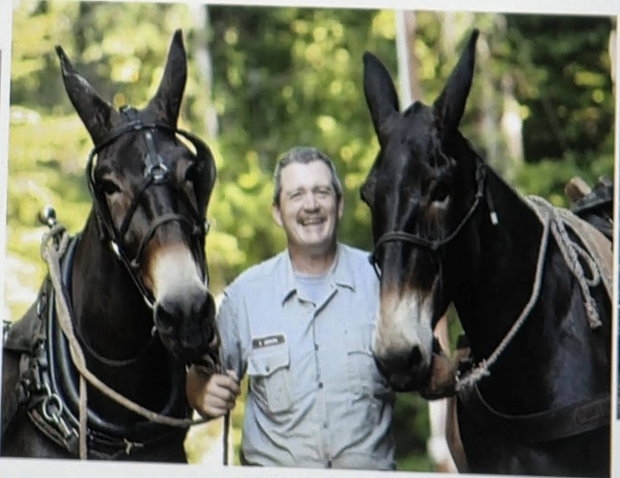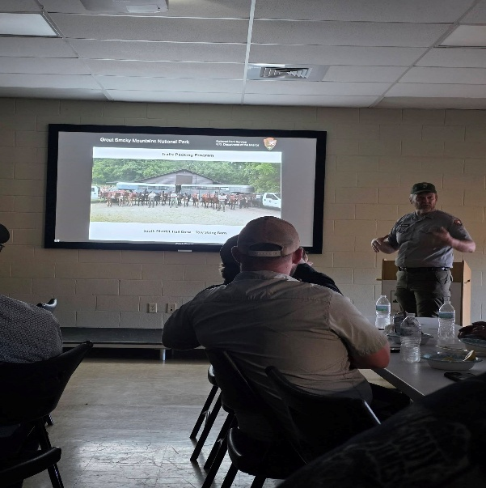
Danny Gibson GSMNP

Croatan, Uwharrie, Big Creek Chapters
All three of these chapters stay busy with reoccurring trail clearing. Uwharrie and Croatan were unaffected by the Hurricane however staffing has often been redirected to those areas, creating bottlenecks for workday repair approvals and delays in paperwork. These chapters area active in hosting youth days, poker runs, member camp outs and other creative fun fundraising/member building events. Big Creek continues to be a small but mighty chapter that is responsible for an astronomical amount of planning for the Great Smokey Mountain National Park chainsaw window whereby they are allowed to use mechanical means to clear the trails in the park. This event tallies up hundreds of work hours for BCHNC, clearing over a hundred miles of trail and several hundred trees cleared. Its astounding what they can do and we are grateful for the years of leadership that David Michael has put into this event.

Post Hurricane Volunteer hours

Total Basic Hours |  | 13894 | $34.79 | $483,372.26
Total Skilled Hours |  | 4227 | $52.19 | $220,607.13
Total Trail Recon Hours |  | 0 | $34.79 | $0.00
Total LNT - Education |  | 16 | $34.79 | $556.64
Total Public Meetings |  | 0 | $34.79 | $0.00
Total Administative Service |  | 2544 | $34.79 | $88,505.76
Total Travel Time |  | 1930 | $34.79 | $67,144.70
Total Hours |  | 22611
Wilderness Trail Miles |  | 24
National Scenic Trail Miles |  | 0
Other Trail Miles |  | 0
Total Trail Miles |  | 24
Personal Vehicle |  | 35658 | $0.67 | $23,890.86
Stock Hauling |  | 620 | $1.35 | $837.00
Total Travel Miles |  | 36278
Power Equipment |  | 618 | $35.00 | $21,630.00
Heavy Equipment |  | 355 | $140.00 | $49,700.00
Total Equipment Hours |  | 973
Total Stock (Pack and Saddle)
Total Stock Days |  | 332 | $125.00 | $41,500.00
Total Donations |  | $8,905.00 |  | $8,905.00
 |  |  | Total | $1,006,649.35

Challenges we face in NC
MTB 32mph https://photos.app.goo.gl/YNLRiB6hLoxvCQnJA

Campsites across multiuse trails: 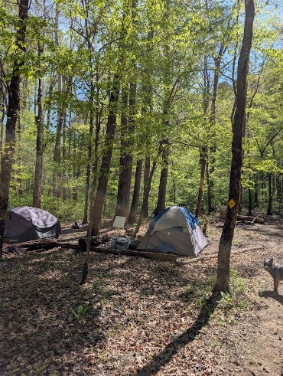

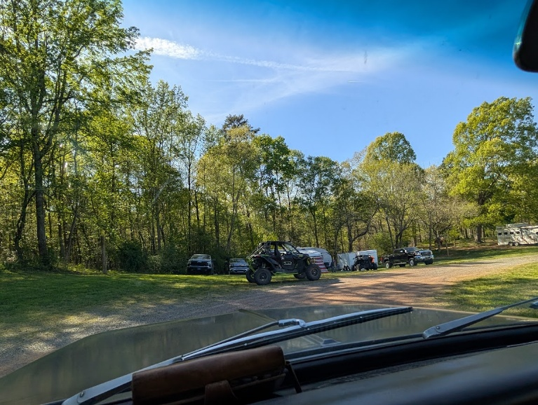
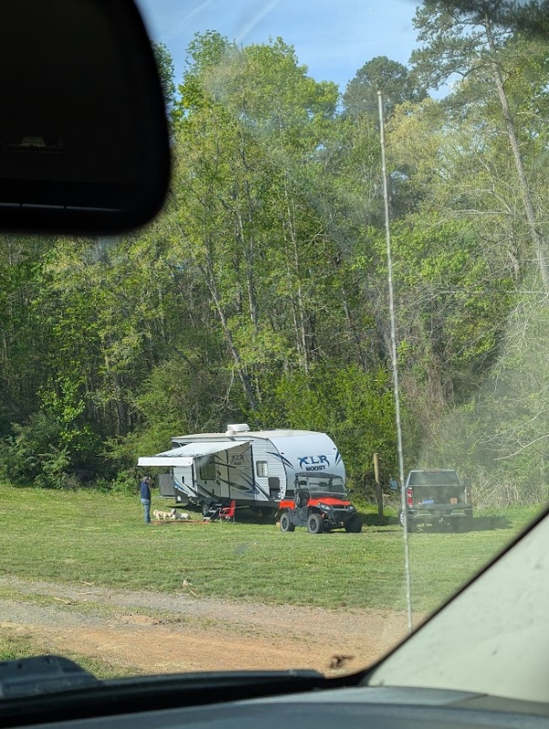ATVs in horse camp, limiting site availability

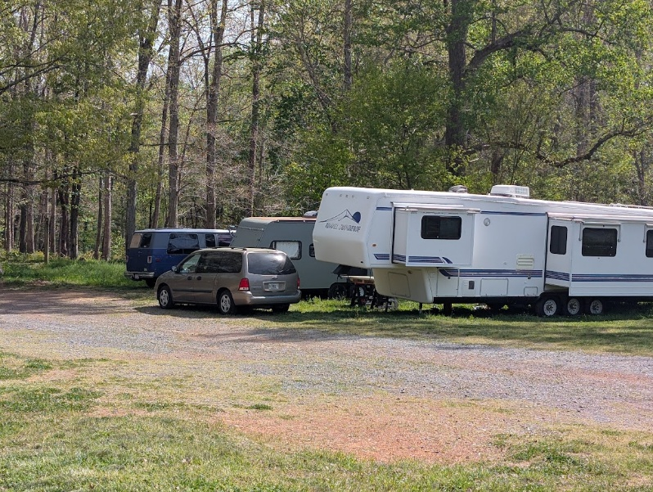homeless encampments in horse camps

User conflicts are at astounding numbers with too many users and limited trail mileage:

