**NW Horse Fair Albany Oregon**

**Story by: Jennifer Paulson, Chairperson for this BCHO Event**

Back Country Horsemen of Oregon was represented by three chapters again this year.

Emerald Empire BCHO, Territorial Riders BCHO, and West Cascade BCHO.

We have a huge booth in horse barn (four stalls with stall fronts and dividers removed).

The booth is decorated on Thursday. Logs and sawbuck come in early, then tables with fold outs and BCHO information and pack equipment for the two demos that are given in arena on Friday and Saturday.

The booth is very popular is because we have the BCHO Hot Shot Saw team and other BCHO sawyers at booth to demonstrate and teach youth and adults how to saw. The kids love to saw. So do adults and parents. We give the kids prizes for sawing. Compasses, space blankets, whistles, small flash lights etc. and card with lanyard for them to wear and show that they sawed. Children or sawyers also take the rounds that they sawed off logs. Back Country

Horsemen of America and BCHO gave us a Grants this year that covered the cost of prizes, different size leather gloves, covered expenses, space rent, passes for workers …. Insurance.

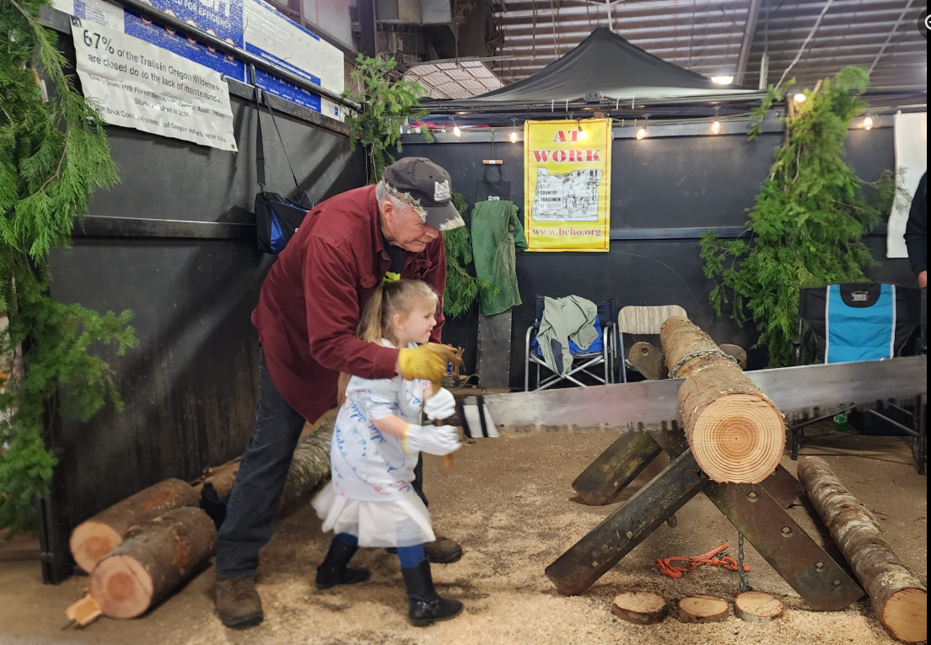

Presentations:

Friday: Emily Elias of Emerald Empire BCHO gave a packing demonstration in arena for one hour.

Their presentation was about what you do when you arrive at camp. Proper distance from water, highline, hobbling, unloading pack horses with supplies, also being prepared to clean some trail if necessary. West cascade supported other pack animals and help.

Saturday: Bert Morris talked at presentation explaining and giving history of Crosscut saw.

West Cascade had a sawing demonstration where they had a competition between a new 2025 Stihl chain saw with Rick Grass operator and Arden Corey and Eric Dahl sawing with crosscut saw. The Crosscut sawyers won even with a hang up on log. They barely won. It was exciting.

George Johnson then talked about the pack strings, equipment for sawing trees, and youth sawing:

We had two pack strings West Cascade BCHO and Emerald Empire BCHO in arena showing their saw tools off and how to pack saws and equipment for moving logs.

We had youth BCHO members with their own smaller cross cut saw sawing a log and they shared the sawing with two other youth in BCHO.

Lots of good questions from the audience for both presentations.

We got some new on spot members and several people picked up information.

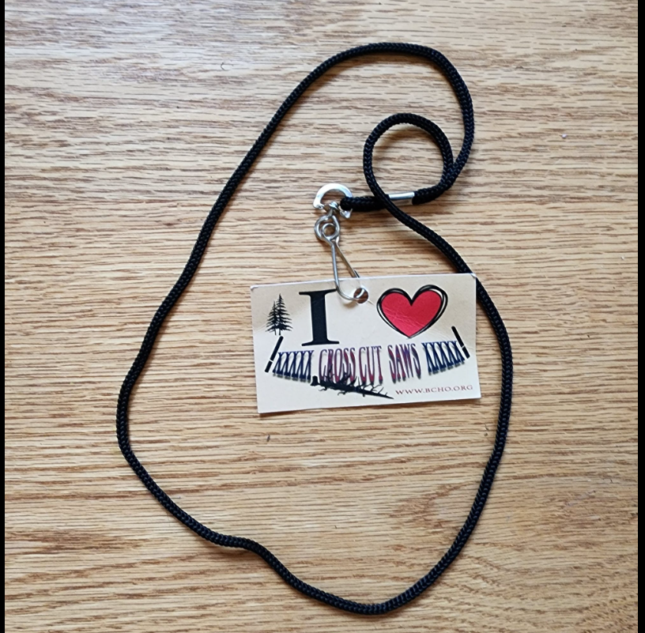

This was a FUN and EDUCATIONAL event and Horse Fair likes us.

Planning for next year already.