**Wildland Firefighter Hearing Conservation**

*Noise Exposure – Interim Report*

Although employees may be using hearing protection, it may not provide the appropriate level of decibel

reduction and therefore not provide sufficient protection.

This assessment will provide the information necessary to assure the right level of hearing protection is being recommended for firefighters engaged

in specific activities.

**Photo by Kari Greer, U.S. Forest Service**

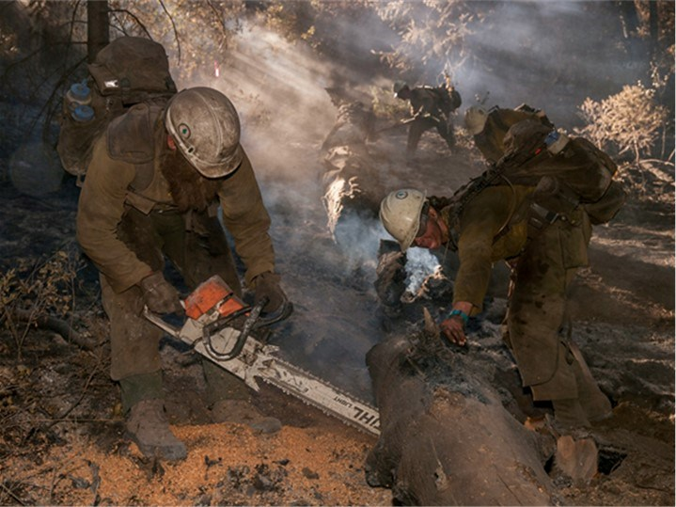

**George Broyles**

Fire & Fuels Project Leader gbroyles@fs.fed.us

208.387.5638

USDA Forest Service

National Technology and Development Program Boise, Idaho

**April 2016**

|  |
| --- |
| **Project Highlights**   * Noise exposure measurements were taken on 182 wildland firefighters while engaged in fire suppression efforts.      * Dosimeters recorded sound levels on firefighters that could be exposed to harmful levels of noise: sawyers, swampers, equipment operators, etc.      * Initial analysis indicates that firefighters undertaking certain jobs exceed safe exposure levels.      * Firefighters that exceed the Occupational Safety and Health Administration (OSHA) Action Level and Permissible Exposure Level are required to be in a Hearing Conservation Plan.      * Adequate hearing protection must be worn to protect firefighters exposed to unsafe levels. |

**Contents**

1. Introduction………………………………………………………………..……………. 3

1. Noise Exposure: A Health and Safety Concern…………………………… 3

1. Project Objectives……………………………………………………………………… 4

1. Field Protocols and Data Collection…………………..………………………. 4

1. Initial Findings…………………………………………………………………………… 5

1. Hearing Conservation Plan………………………………………………………… 6

1. Hearing Protection….…………………………………………………..……………. 7

1. Next Steps………………………………………………………………………………… 8

1. Acknowledgments…………………………………………………….……………… 8

1. References……………………………………………………………..………………… 9

***Noise Induced Hearing Loss is preventable—and is irreversible.***

## 1. Introduction

There are numerous reasons to conduct a noise exposure assessment on wildland firefighters. The most obvious is the Occupational Safety and Health Administration (OSHA) requirement that all employers must undertake an exposure assessment to determine the extent of employee noise exposure and to implement specific actions if the exposure exceeds permissible levels.

Perhaps more importantly, another reason to undertake a noise exposure assessment is to determine the levels of noise firefighters are exposed to because noise exposure presents serious and irreversible damage to employees’ hearing. Hearing loss from noise exposure is referred to as Noise Induced Hearing Loss (NIHL).

## 2. Noise Exposure: A Health and Safety Concern

NIHL is caused by overexposure: listening to sound that is too loud for too long, or exposure to a single activity such as an explosion or a loud concert.

There are two important facts to understand when talking about NIHL: it is preventable and it is irreversible.

Usually, NIHL is progressive and occurs gradually over many years. Likewise, it is painless and cannot be detected in the early stages by traditional audiograms (NIH, Kujawa).

Although the most obvious condition with NIHL is diminished hearing, it also includes tinnitus (buzzing or ringing in the ears) and other auditory disorders. Tinnitus can affect the overall quality of life by interferring with sleep and concentration. It can also cause anxiety and depression in some people (American Tinnitus Association [www.ata.org)](http://www.ata.org/).

The combination of NIHL and tinnitus can cause impaired speech discrimination. This inability to hear and understand speech poses a risk for wildland firefighters when it impedes their ability to hear warning signals and communicate clearly.

The Department of Defense states that 50 to 60 percent of situational awareness comes from hearing ([http://hearing.health.mil/)](http://hearing.health.mil/). According to the Department of Defense, “Hearing loss significantly impedes situational awareness and communication…”

Additional concerns associated with NIHL are increased morbidity, chronic disease, anxiety, depression, sleeping disorders, hypertension, loss of performance and increased accident/injuries (Kirchner et al., Cantley et al.).

Causes for increased accidents and injuries include: distraction, increased fatigue, loss of concentration, and the inability to hear warning signals or other critical verbal communication.

***This assessment will provide the information necessary to assure the right level of protection is being recommended for firefighters engaged in specific activities.***

In addition, susceptibility to NIHL can be influenced by other factors, including genetic predisposition, environmental contaminants (ototoxicity), medications, medical conditions and personal behaviors (smoking).

Noise exposure during non-working hours can also contribute to NIHL (ear buds, loud music, and weapons) (Kirchner et. al.). Noise dose (damage) is cumulative and never decreases over time even though exposure may fluctuate. Therefore, the sooner employees recognize and work to protect their hearing, the better they will be.

## 3. Project Objectives

The objective of this project is to identify which (if any) activities place firefighters at increased risk of NIHL. Excess risk is based on the sound level measured in decibels (dB) and the length of exposure.

Although employees may be using hearing protection, it may not provide the appropriate level of attenuation (decibel reduction) and therefore, not provide sufficient protection.

This assessment will provide the information necessary to assure the right level of protection is being recommended for firefighters engaged in specific activities.

## 4. Field Protocols and Data Collection

Field protocols were developed and equipment selected to assure accurate noise exposure data were collected. Working closely with hearing specialists from the National Institutes of Occupational Safety and Health compliance with accepted industrial hygiene practices was assured.

Noise dosimeters were attached to the firefighter that recorded sound levels continuously. These dosimeters measured decibels in the “A scale” which most closely resembles human hearing.

Data collection crews observed the firefighters throughout the shift. In addition to recording work activity, numerous other variables were also recorded which will help determine if other factors may influence exposures.

#### Field Observations

##### 182 Firefighters 2,163 Hours 14 Work Activities

***Based on the initial analysis, wildland firefighters exceed the OSHA PEL and action level***

***while undertaking various work activities.***

## 5. Initial Findings

OSHA sets exposure limits to protect employees from unsafe exposures. Noise exposure limits are twofold. The OSHA action level is a time weighted average (TWA) of 85 dB over eight hours.

A TWA is typically set for a “normal” 8-10-hour work day and a 40-hour work week. It is an average concentration across the daily and weekly work shift that should not be exceeded and will provide a safe work environment for a career length exposure.

The OSHA Permissible Exposure Level (PEL) is 90 dB, also an 8-hour TWA. Employees who meet or exceed the action level are required to be placed in a Hearing Conservation Plan (HCP) and undergo annual audiograms.

Employees who meet or exceed the PEL must also be placed in a HCP and take steps to reduce their exposure to 90 dB. This can be done by wearing appropriate hearing protection, reducing the length of time of the exposure, removing the source of noise, or moving the noise source farther away.

Based on the initial analysis, wildland firefighters exceed the OSHA PEL and action level while undertaking various work activities (Figure 1). Virtually all (95.6%) sawyers and swampers (S/S) assessed exceed the OSHA action level. All the masticator/chipper operators and helicopter pilots assessed exceed the OSHA action level. Similarly a high percentage of firefighters also exceed the OSHA PEL (Table 1).

**Figure 1. Percent of subjects to exceed the exposure limit per work category. Error bars (the thin black lines) represent the variance level in each data set.**

**They show a 95% confidence interval.**

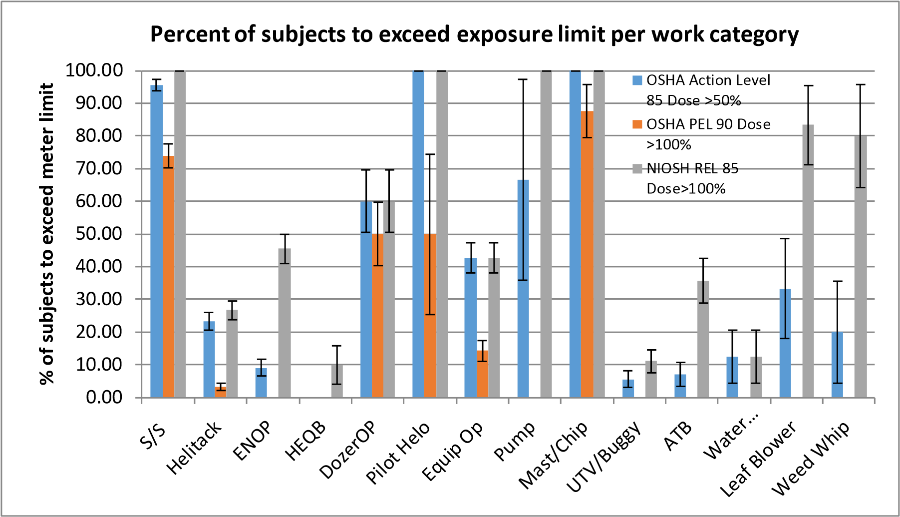

**“S/S”: Sawyers/Swampers. “ENOP”: Engine Operator. “HEQB”: Heavy Equipment Boss. “ATB”: Air Tanker Base. “Water”: Water Tender.**

**Table 1. Percent of subjects that exceeded exposure limits ± 95% confidence interval and maximum time weighted average (TWA) per work activity for OSHA Action Level 85 dBA, OSHA PEL 90 dBA.**

**Sample size (n) shown for each work category.**

|  |  |  |  |  |  |
| --- | --- | --- | --- | --- | --- |
| **Work**  **Activity**  **Category** | **Subjects to Exceed**  **OSHA Action Level (%)** | **Subjects to**  **Exceed OSHA PEL (%)** | **TWA Maximum Value**  **OSHA Action Level (dB)** | **TWA Maximum**  **Value OSHA PEL (dB)** | **n** |
| **S/S** | 95.7 ± 1.7 | 73.9 ± 3.7 | 103.1 | 102.9 | 23 |
| **Helitack** | 23.3 ± 2.8 | 3.3 ± 1.2 | 91.5 | 90.7 | 30 |
| **ENOP** | 9.1 ± 2.6 | 0.0 | 88.1 | 87.7 | 22 |
| **HEQB** | 0.0 | 0.0 | 81.7 | 78.9 | 10 |
| **DozerOP** | 60.0 ± 9.6 | 50.0 ± 9.8 | 111.6 | 111.5 | 10 |
| **Pilot Helo** | 100.0 | 50.0 ± 24.5 | 92.3 | 92.2 | 4 |
| **Equip Op** | 42.9 ± 4.6 | 14.3 ± 3.3 | 94.0 | 93.7 | 21 |
| **Pump** | 66.7 ± 30.8 | 0.0 | 88.7 | 85.4 | 3 |
| **Mast/Chip** | 100.0 | 87.5 ± 8.1 | 102.8 | 102.7 | 8 |
| **UTV/Buggy** | 5.6 ± 2.5 | 0.0 | 85.5 | 82.9 | 18 |
| **ATB** | 7.1 ± 3.6 | 0.0 | 87.9 | 85.1 | 14 |
| **Water Tender** | 12.5 ± 8.1 | 0.0 | 85.5 | 79.2 | 8 |
| **Leaf Blower** | 33.3 ± 15.4 | 0.0 | 86.5 | 86.0 | 6 |
| **Weed Whip** | 20.0 ± 15.7 | 0.0 | 86.5 | 86.0 | 5 |

## 6. Hearing Conservation Plan (HCP)

An OSHA Hearing Conservation Plan (29 CFR 1910.95(c)(2)) is comprised of several distinct components. As stated previously, employees who exceed the action level or are exposed to ≥90 dB TWA are required by law to be placed in a HCP.

The first requirement for a HCP is the initial noise assessment. The Wildland Firefighter Hearing Conservation Project meets this first requirement.

**OSHA Requirements for a HCP**

* Audiometric Testing: including baseline and annual audiograms.

* Hearing Protection Devices (HPDs): employers must provide HPDs, ensure they are worn and give employees the opportunity to select their HPDs from a suitable variety.
* Training: employers must institute training and ensure employee participation.

This must be repeated annually.

* + Training must include the effects of noise on hearing, purpose of hearing protection, instruction on selection, fitting, use and care.

* Recordkeeping:
  + Employers must maintain an accurate record of all employee exposure measurements for two years.
  + Employers must maintain employee audiometric test records for the duration of the individual’s employment.
  + All records must be provided upon request to:
    - Employees, former employees, or a designated representative.
    - OSHA.

***Although most of the firefighters assessed to date wore some type of hearing protection, few had received proper training on the use and care of these devices.***

## 7. Hearing Protection

There are several ways to reduce exposure to harmful levels of noise: reduce the exposure time, move away from the source, or wear hearing protection.

In some cases, such as heavy equipment bosses or pump operators, it may be possible to get farther away from the source, at least for a portion of the shift. Sawyers and swampers do not have that option.

Regardless of the position on the fire, anyone in close proximity to loud noise should wear an appropriate HPD. Although most of the firefighters assessed to date wore some type of hearing protection, few had received proper training on the use and care of these devices. Importantly, many of these firefighters were not aware of the Noise Reduction Ratio (NRR) of their chosen units. Noise Reduction Ratio is the value each HPD is given to show how much noise reduction the device is designed to provide.

Employees exposed to noise exceeding the PEL must wear HPDs that attenuate the exposure to 90 dB or lower. Every HPD will have an NRR. However, these values are determined by the manufacturer in a controlled setting.

OSHA recommends a correction factor be applied to the published NRR. The NRR should be reduced by 7 dB and then multiplied by 50%. For example, if the NRR is 20 dB, the actual attenuation would be closer to 6.5 dB ((20-7)**\*** 50%).

If an employee is exposed to a TWA of 98 dB and is wearing a HPD with a stated NRR of 20, these devices would not be adequate as the employee exposure would still exceed 90 dB.

**\*See OSHA Appendix IV: C Methods for Estimating HPD Attenuation:**

[**(https://www.osha.gov/dts/osta/otm/noise/hcp/attenuation_estimation.html)**](https://www.osha.gov/dts/osta/otm/noise/hcp/attenuation_estimation.html)**.**

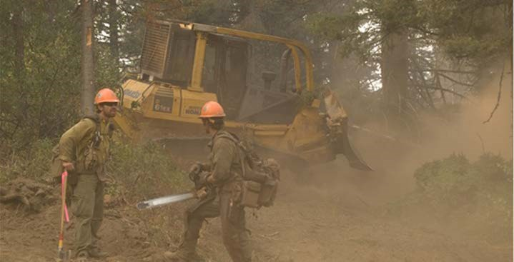

**Photo by Kari Greer, U.S. Forest Service**

**Photo by Kari Greer, U.S. Forest Service**

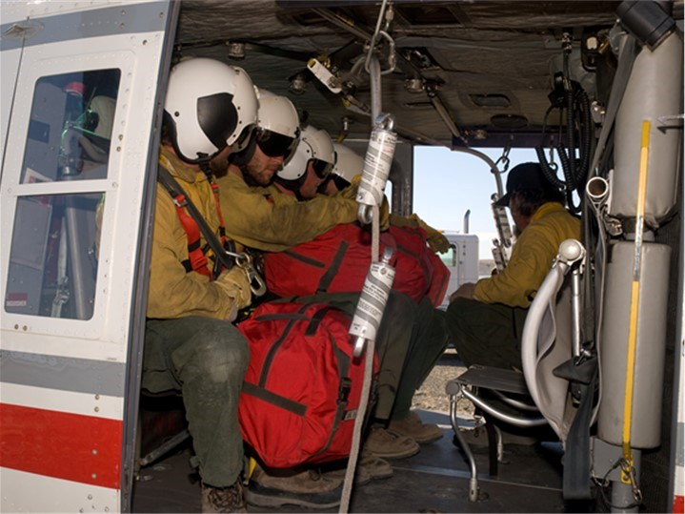

## 8. Next Steps

Data collection will continue during the 2016 fire season. Additional samples will also allow for finer analysis by equipment type to determine if the make/model of chainsaws, dozers etc. have a significant difference on exposure.

Exposure tables will be developed that will show the exposure level for various wildland fire jobs and equipment. These tables will also show the appropriate level of hearing protection needed for each job and category of equipment.

### 9. Acknowledgements

The author would like to thank the following people for their work in collecting the noise assessment data published in this report.

* Robert Manwaring, Amanda Stachowsky, Jeff Bade, and Max Sage.
* Marissa Caringella (data management and analysis).
* Thanks, also, to each firefighter who participated in this project. Without your support, this work would not have been possible. It is hoped that the findings presented in this document will help protect your hearing and general wellbeing.

# 10. References

Cantley, LF, Galusha D, Cullen MR, Dixon-Ernst C, Rabinowitz PM, Neitzel RL, Association between ambient noise exposure, hearing acuity, and risk of acute occupational injury, Scandinavian Journal of work, Environment & Health, 2015; 41(1) 75-83.

Kirchner, D Bruce MD, Evenson, Col Eric MD, Dobie, Robert A. MD, Rabinowitz, Peter

MD, Crawford, James MD, Kopke, Richard MD, and Hudson, Warner, T. MD, Occupational Noise-Induced Hearing Loss, *JOEM* Volume 54, Number 1, January 2012, 106-108.

Kujawa, S, Liberman M, Adding Insult to Injury: Cochlear Nerve Degeneration after “Temporary” Noise-Induced Hearing Loss, The Journal of Neuroscience, November 11, 2009 29(45) 14077-14085.

National Institutes of Health, U.S. Department of Health and Human Services, National Institute on Deafness and Other Communication Disorders, Noise-Induced Hearing Loss, March, 2014 NIH Pub. NO. 99-4233 P 1-4.

Niquette, P, Noise Exposure: Explanation of OSHA and NIOSH Safe-Exposure Limits and the Importance of Noise Dosimetry, Etymotic Research Inc., June 2014, Canadian Hearing Report: 2014, Vol. 9 Issue 3 p22.

**Photo by Kari Greer, U.S. Forest Service**

