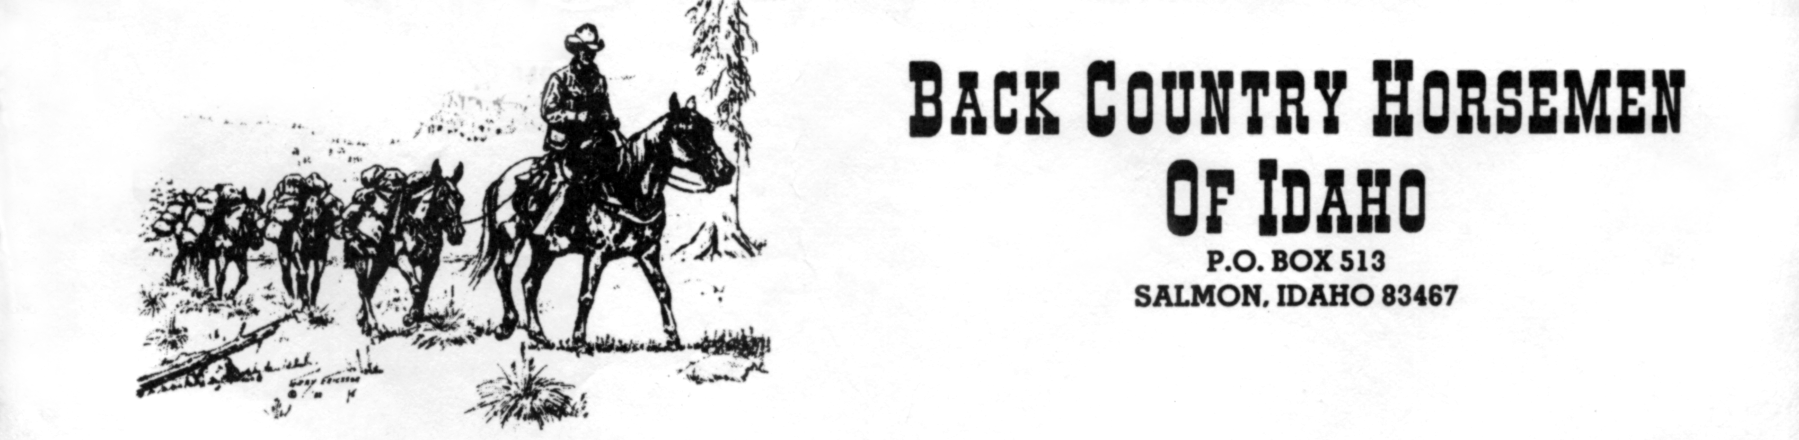
Date

Idaho Bike Shop
Address
Anywhere, ID

All trail users must work at sharing multiple use trails so that no single group will be shut out of an area. It is imperative that user groups work together to educate the public and each other about interacting in a positive manner.

The enclosed poster depicts what equines see when they encounter a silent, fast moving bike and rider. It tells the story of a basic fear equines have of predator animals and why, if caught unaware, they react to a biker's presence.

Please accept this poster from Back Country Horsemen of Idaho. By posting this in your shop, it is our hope that mountain bikers and equestrians can further a relationship of mutual understanding for the betterment of the trail resource!

Sincerely,

Phil Ryan, Chairman
Back Country Horsemen of Idaho

